RICUPERO, Rubens, Brazilian diplomat and fifth Secretary-General of the United Nations Conference on Trade and Development (UNCTAD) 1995-2004, was born on 1 March 1937 in São Paulo, Brazil. He is the son of João Ricupero, a locksmith and small business owner, and Assumpta Jovine. On 2 September 1961 he married Marisa Parolari, a specialist in Brazilian artistic patrimony at the Ministry of Culture. They have three daughters and one son.

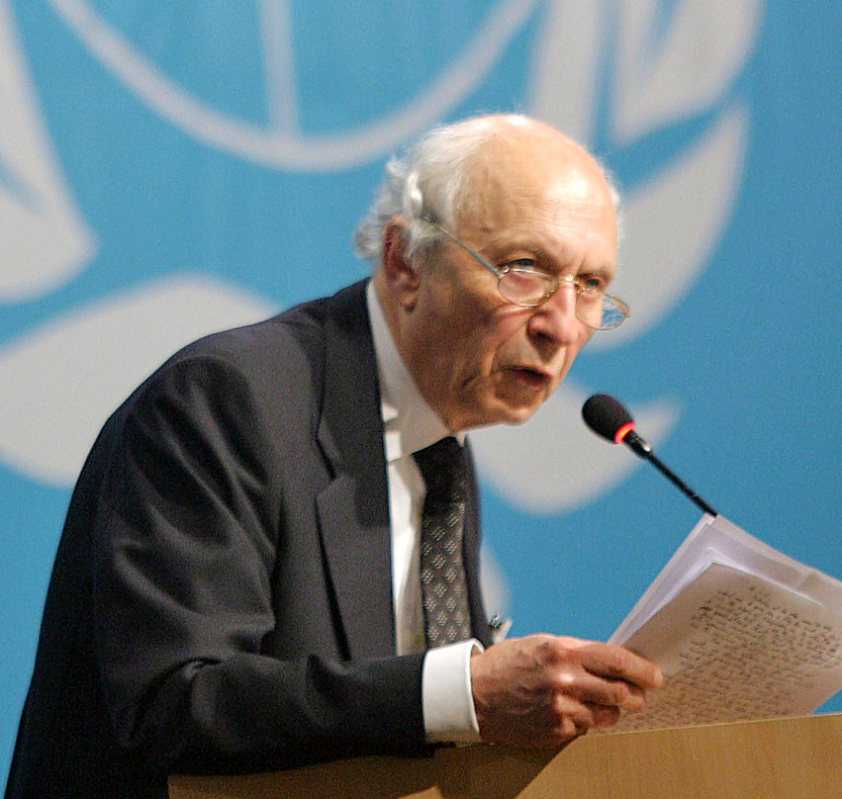
Source: Ricupero, 14 June 2004, Inaugural Ceremony UNCTAD in Sao Paulo, Photo UN721446, Photographer Marcos Issa
In The Creation of the WTO on YouTube: www.youtube.com/watch?v=T1SRThXkG2Y, 11 November 2011

As a Paulistano, a person born in the capital city of São Paulo, of Italian descent, Ricupero spent his childhood and school years in his hometown. He was the oldest of three brothers and was raised in Brás, a neighbourhood where low-income industrial workers lived at a time when Brazil was rapidly becoming urban and industrialized. His father worked as a locksmith before running his own business, while his mother took care of the family. Although his father never made much money, he was able to send his three sons to university. Ricupero’s main interests were in the areas of history and economics, but he studied law at the University of São Paulo, a state-sponsored public university, between 1955 and 1959. He was the first family member to earn a Bachelor’s degree. In 1955 he took part in poverty alleviation activities carried out in the slums of São Paulo under the leadership of Dom Helder Camara, the Deputy Archbishop of Rio de Janeiro. French Catholic thinking influenced Ricupero since his early days in university. He became aware that the radical French philosophy of separating state affairs from religion did not exist in Brazil and developed his own belief that a separation between religion and government in a modern secular state should not be an obstacle to the actual engagement of Christians in progressive social, educational and cultural causes. Ricupero became a follower of two religious philosophers. One was Jacques Maritain, an influential twentieth-century French Catholic philosopher who considered material and spiritual development a key issue for all men and women, defining development as the promotion of all men and of man as a whole, a tendency Maritain defined as ‘integral humanism’. The other was Louis-Joseph Lebret, a Dominican friar who founded the Economy and Humanism movement and wanted to put the economy at the service of man. Unlike several close relatives, who were prominent Communist trade union leaders, Ricupero followed the ideas of Maritain and Lebret to develop his vision on development. He was not affiliated to the Brazilian Christian Democratic Party, but he attended its open sessions from the mid-1950s until the 1960s. However, he did not agree with the increasingly Marxist and non-democratic orientation followed by some leading members of the youth wing of the Brazilian Catholic Action at his university who were under the influence of the Cuban regime after the 1959 revolution. This indirect and ultimately inconclusive involvement with future Marxist revolutionary movements led to his indictment and investigation by the Brazilian military regime after its 1964 coup d’état.
A legal career proved not to be Ricupero’s calling. Instead, he decided to become a diplomat and successfully completed a public contest for admission to the Rio Branco Institute, the Brazilian diplomatic academy, in 1958. His diplomatic career started with a position in Vienna, Austria, where he remained for three years between 1963 and 1966. His investigation by the military regime took place while he was serving as a diplomat in Vienna. He was not convicted, but his diplomatic career was negatively affected in its early stages. In 1966 Ricupero was sent to the Argentinean capital city of Buenos Aires, where he stayed until 1969. From 1969 to 1971 he worked in Quito, Ecuador. During his time in these two South American countries he kept close to Catholic life and the intellectual and cultural communities. He then became the director of the Cultural Division at the Foreign Ministry in Brasília, focusing on the promotion of cultural relations with African countries and the development of African studies in Brazil. In 1974, when the Brazilian military government first admitted the prospect of a democratic transition, he was made counsellor in Washington DC, where he met his new chief, Ambassador João Augusto de Araújo Castro, a former Minister of Foreign Affairs of Brazil (1963-1964) who influenced his approach to international problems. His activities at the Embassy in the United States (US) lasted until 1977, when he returned to become the Head of the South America-2 Division of the Brazilian Ministry of Foreign Affairs, which dealt with issues related to countries at the Northern part of the South American continent, from Bolivia to French Guyana. His main function was to negotiate the Amazon Cooperation Treaty that Brazil, together with seven other countries in the region, signed in 1978. In 1981 he took over as Director of the Americas Department. In 1979 Ricupero also started to teach courses at the Rio Branco Institute and the Federal University of Brasília where he was among the founders of the first International Relations graduate programme in Brazil. He taught International Relations Theory on the basis of his independent reading of the literature. His academic career, which had started in a time when priests and diplomats were regarded as sufficiently prepared to lecture, lasted until 1987, when he moved to Switzerland. His son Bernardo later became a tenured professor in Brazilian social thought at the University of São Paulo.
By the end of the military government period Ricupero became an informal international affairs adviser for Brazil’s-then-candidate and future President Tancredo Neves (elected January 1985) and accompanied him during his trips to Europe, the US and Latin America. Neves passed away in April 1985 and even before his successor, Vice-President José Sarney, assumed the presidency, Sarney appointed Ricupero to the position of Deputy-Chief of Staff, and later Special Assistant to the President. Ricupero was given responsibility for issues relating to developmental economics, particularly relevant because of existing problems in the bilateral trade between Brazil and the US and the negotiations that resulted in the launch of the Uruguay Round of the General Agreement on Tariffs and Trade (GATT) in 1986. He accompanied the Brazilian president in his official visits abroad and advised him on negotiations related to the international debt crisis, the International Monetary Fund and commercial problems with Argentina and the US. Much of his practical experience in the economic realm resulted from these activities in the years 1985-1987. In 1987 he was appointed Ambassador at Brazil’s Permanent Mission to the United Nations (UN) and moved to Geneva, where he worked with multilateral organizations, in particular in GATT negotiations. In 1989 he became Chair of the GATT Committee on Trade and Development, and in 1990 he was elected Chairman of the GATT Council of Representatives, becoming the Chairman of the GATT Contracting Parties in 1991. Ricupero succeeded India’s Ambassador, S.P. Shukla, as Chair and Spokesperson of the Informal Group of Developing Countries (1989-1991).
In 1991, when the Brazilian Ambassador in Washington DC, Marcilio Marques Moreira, was appointed to head Brazil’s Ministry of Finance, Ricupero was appointed Ambassador to the US, the most prestigious post in Brazilian diplomacy. During his period in the US, the domestic situation in Brazil was aggravated, chiefly due to the constitutional impeachment of President Fernando Collor de Mello in 1992. When the new President Itamar Franco took office by the end of the year, Ricupero was invited to become the new Minister of Finance, but he refused. In June 1992, although still Ambassador in the US, Ricupero was chosen as the coordinator of the Finance Committee of the UN Conference on Environment and Development in Rio de Janeiro that drafted chapter 33 of Agenda 21, which dealt with the issue of financing sustainable development. He helped in the negotiations to increase the resources of an international fund for environmental issues. The proposal to use the World Bank’s revenue as a source of an ‘environmental dividend’ and other suggestions to substantially raise the level of financial aid for environmental purposes ran into strong opposition from the US and other developed countries. Ricupero remained in Washington DC until 1993, when, in response to the massacre of Yanomami Indians in the Brazilian Amazon region, President Itamar Franco, aware of Ricupero’s previous involvement with Amazonian issues, created the Ministry of the Amazon (that merged with the Environment Ministry) and appointed him as Minister. This was the official reason for Ricupero’s return to Brazil, though rumours claimed that the actual reason was to have him at hand to replace the Minister of Finance, Fernando Henrique Cardoso, who was generally expected to leave the government in early 1994 in order to run for the presidency. Indeed, when Cardoso resigned in March 1994, Ricupero was promptly appointed as his successor at the Ministry of Finance. He became instrumental in the preparation and approval of measures to implement the Plano Real, a set of macroeconomic measures to combat monetary inflation that was running at the incredibly high rate of two per cent per day. His mission was to persuade the population, which had grown sceptical after the failure of seven anti-inflation plans (three of them with changes in the currency), that this time inflation would finally be conquered. To this end it was essential to launch a new currency, the Real, on 1 July 1994. This happened and in the following months it brought inflation to a swift end. However, while waiting to have an interview on television on 1 September, Ricupero used inappropriate terms, which gave the impression that there was ‘unscrupulous’ use of positive inflation indicators in favour of presidential candidate Cardoso. This part of the interview was accidentally broadcasted nationally to those who had a satellite dish and resulted in the ‘Satellite Antenna Scandal’. The next day Ricupero resigned as Minister of Finance. During his time in office he had been Brazil’s unofficial candidate for the presidency of the new World Trade Organization (WTO), but the candidature was put aside by the time of his resignation. Ricupero returned to diplomacy and was appointed Head of Brazil’s Embassy in Rome, Italy. He remained in that position for a short time only, as in June 1995 UN Secretary-General Boutros Boutros-Ghali invited him to become the new Secretary-General of the UN Conference on Trade and Development (UNCTAD).
When Ricupero joined UNCTAD on 15 September 1995, it was facing a deep existential crisis because the US and other developed states saw it as a redundant institution, particularly after the creation of the WTO in January 1995, and therefore irrelevant to the management of world economic issues. Ricupero proposed dramatic reforms to the institution’s operating structure and mobilized the support of the developing countries against the argument that UNCTAD ceased to be necessary. He proposed to reinvent UNCTAD and to redefine its identity in order to highlight the differences between the legal work performed by the WTO in trade matters and UNCTAD’s emphasis on development, even if development should be, in part, a consequence of trade. UNCTAD’s specificity would be highlighted in analysing the impacts of trade negotiations on development, in providing developing countries the intellectual capability needed to define their own trade interests, and in acquiring the negotiating skills to pursue and defend these interests in international arenas. Such functions could have never been performed by the WTO, which has the duty to act as the impartial secretariat of negotiations. Impressed by the impact of the French general strike of 1995, Ricupero also suggested to UNCTAD members that they should formally include civil society organizations in their debates through a sort of Development Council. However, most countries were not ready to accept such a revolutionary change, which would put civil society almost at the same level as governments. Despite strong reactions by a few countries, Ricupero successfully carried out the reform, living up to the standards set by the UN Secretariat in New York. During this reform UNCTAD reduced its functional divisions from nine to four. For Ricupero the pursuit of more equitable trade relations and the improvement of an imbalanced and unfair multilateral system was UNCTAD’s ethical imperative. UNCTAD should not merely be a ‘technical’ organ, but rather approach issues from a strong and explicit moral perspective, taking into account the social and economic differences between states. In some important ways UNCTAD under Ricupero assisted in developing influential ideas and, in doing so, indirectly shaped the international debate on trade relations.
The WTO’s position proved weakened as a result of the massive anti-globalization protest activity surrounding its Ministerial Conference at the Washington State Convention and Trade Center in Seattle, Washington, in December 1999. UNCTAD X, the tenth session of the Conference held in Bangkok in February 2000, proved a good opportunity to make a conceptual contribution to the ‘post-Seattle scenario’ and the re-establishment of the developing countries’ confidence in the multilateral trading system. UNCTAD’s contribution eventually helped pave the way for launching a new WTO round of negotiations in Doha in November 2001, whose specific goal was to address the issues of developing countries in a so-called Development Agenda for Trade Negotiations. However, circumstances had dramatically changed as a result of the terrorist attacks on the US on 11 September. While politics and economics were mutually reinforcing, trade barriers were being rebuilt. Wars were fought in Afghanistan and Iraq and dangerous confrontations took place around the globe, almost all of them involving the US and its Western allies. During most of his second term in office (2000-2004) Ricupero led UNCTAD against the background of this shift in international security and its strong impact on international trade and development opportunities. Ricupero’s efforts were driven towards the creation of a better globalization through de-regulation and fairer negotiations which would enable countries to lift themselves out of poverty. ‘Quality integration’ in the globalization process became a catchword often employed to mean not only high-value exports (from the viewpoint of the least developed countries) but also a type of environmentally friendly and socially balanced development. The WTO negotiations in Cancún, Mexico in 2003, meant to continue the Doha Development Agenda, collapsed after a few days because of disagreement among the member states on a framework to continue negotiations. All UNCTAD XI in June 2004 in São Paulo, Brazil, could do was to underpin the case for development-friendly policies in support of developing and transition economies.
Ricupero remained as Secretary-General until 15 September 2004 when he, at the age of 67, retired from UNCTAD after having served two terms in office, having already retired from the Brazilian diplomatic service in 1995. Although he handed over the organization in better shape than he had found it in 1995, his legacy was somewhat unfinished, as he had been unable to implement his developmental agenda in full, mostly due to massive economic constraints (the rise of protectionism in world commerce and the weakening of the WTO) and to UNCTAD’s lack of operational ‘teeth’. As he himself once affirmed, the best image to comprehend the functioning of UNCTAD in his time was that of a ‘think tank’, rather than that of a full-fledged bureaucracy. In 2005 he became the Director of the School of Economics and International Relations at Armando Álvares Penteado Foundation, in São Paulo. From 1995 he has been a columnist in the Brazilian newspaper Folha de S. Paulo, in which he has published articles on topics related to politics and economics on a bimonthly basis.

PUBLICATIONS: Três Ensaios sobre Diplomacia Brasileira, Brasília 1989; ‘A Rodada Uruguai e o futuro do sistema multilateral de comércio’ in J. Olympio (ed.), A Nova Inserção Internacional do Brasil, Rio de Janeiro 1993, 19-48; NAFTA and Brazil, Coral Gables 1993 (with S. Estanislav do Amarai and R.C. Kelso); ‘Os Estados Unidos da América e o Reordenamento do Sistema Internacional’ in Temas de Política Externa Brasileira II, Brasília 1994, 84-100; ‘Mercados, poder e futuro’ in Braudel Papers, number 6, São Paulo 1994, available at http://pt.braudel.org.br/publicacoes/braudel-papers/downloads/portugues/bp06_pt.pdf; ‘Los Países en Desarrollo y la Ronda Uruguay: Desencuentros de un Amor Correspondido?’ in La Ronda Uruguay y el Desarrollo de la América Latina, Santiago do Chile 1994, 71-92; Visões do Brasil, Rio de Janeiro 1995; Barão do Rio Branco, Brasília 1995; The Uruguay Round and Beyond: Essays in Honour of Arthur Dunkel, Berlin and Heidelberg 1998 (ed.); O Ponto Ótimo da Crise, Rio de Janeiro 1998; Rio Branco: O Brasil no Mundo, Rio de Janeiro 2000; O Brasil e o Dilema da Globalização, São Paulo 2001; Esperança e Ação, São Paulo 2002; A Folha Explica a ALCA, São Paulo 2003; ‘Nine Years at UNCTAD: A Personal Testimony’ in Beyond Conventional Wisdom in Development Policy: An Intellectual History of UNCTAD 1964-2004, Geneva 2005, ix-xx; Diário de Bordo A Viagem Presidencial de Tancredo Neves, São Paulo 2010.
LITERATURE: R. Dornbusch and S. Edwards, Reform, Recovery, and Growth: Latin America and the Middle East, Chicago 1995; ‘Rubens Ricupero’ in Who’s Who in International Organizations, Volume 2, Munich 2000, 215; ‘Ricupero, Rubens’ in: The International Who’s Who 2011, London 2010, 514; ‘Mr. Rubens Ricupero (Brazil)’, available at http://unctad.org/en/Pages/About%20UNCTAD/OSG/MrRubensRicupero.aspx (all websites accessed on 27 January 2013).

Dawisson Belém Lopes

Version 28 February 2013
March 2015: YouTube film added

How To Cite This IO BIO Entry?
Dawisson Belém Lopes, ‘Ricupero, Rubens’ in IO BIO, Biographical Dictionary of Secretaries-General of International Organizations, Edited by Bob Reinalda, Kent J. Kille and Jaci L. Eisenberg, www.ru.nl/fm/iobio, Accessed DAY MONTH YEAR

